Kanlu£
w w w. ka n l ux . p l

DECLARATION OF CONFORMITY
No. S.CE/EN/0258/V2/2013/187
KANLUX S.A., Objazdowa 1-3, 41-922 Radzionków (POLAND) herewith declares that the product:

CEILING LIGHTING FIXTURE
Type / types:(l) NIKOR DLP-60-W,

(2) NIKOR DLP-75-W
Trade mark: | Kanlu£
Basic parameters: | 220-240V% 50/60Hz; IP20;  [-27: 1 x max.60W  1 x max.75W
is in conformity with the provisions of the following EC directive(s)
(including all applicable amendments):

Directive (LVD) -2006/95/EC
Directive (EMC) -2004/108/EC Directive (RoHS) — 2011/65/EC
references of standards and/or technical specifications applied for this declaration of conformity:
EN 60598-1:2008 +AI :2009

EN 60598-2-1:1989
EN 55015:2006 +AI :2007 +A2:2009 EN 61547:2009
Additional information:
Kanlux S.A. has an implemented Quality Management system according to norm ISO 9001 :2008 confirmed by ISO certificate PL8000069 issued by Bureau Veritas Certification Polska Sp. z 0.0.
Last two digits of the year in which the CE marking was affixed: 08
NWP/686; ID0258; S.CE/187
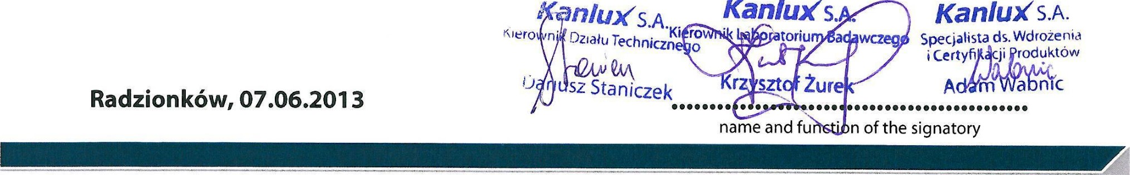
Kanlux S.A. Nr KRS 0000286139 • Sad Rejonowy w Gliwicach, X Wydzial Gospodarczy KRS ul. Objazdowa 1-3, 41-922 Radzionków, Polska Kapital zakladowy: NIP: 645-243-27-93 34000.000 zl • REGON: op{acony 240672104w caloŠci tel. /32/388 74 00, fax /32/388 74 99, e-mail: kanlux@kanlux.pl ING BANK SLhSKl O/BYTOM: 82 1050 1230 1000 0022 5379 7878

