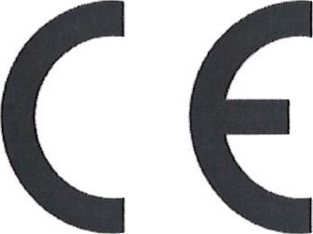
DECLARATION OF CONFORMITY

No. S.CE/EN/0580/V1 /2015/523
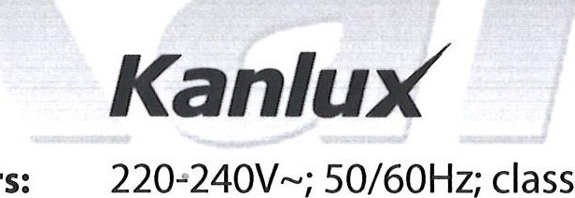
KANLUX SA, ul, Objazdowa 1-3, 41-922 Radzionków (POLAND) herewith declares that the product:
class
l;
IP20;
30W

LED DOWNLIGHT FITTING
Type / types: MISTRAL MCOB 30W-NW
Trade mark:
Basic parameters:
is in conformity with the provisions of the following EC directive(s)
(including all applicable amendments):
Directive (LVD) -2006/95/EC
Directive (EMC) -2004/108/EC
Directive (RoHS) - 2011/65/EC
Directive (EuP) - 2009/125/EC
references of standards and/or technical specifications applied for this declaration of conformity:
EN 60598-1:2008 +AI 1 :2009
EN 60598-2-2:2012
Kanlu£
EN 62471 :2008
EN 55015:2013
EN 61000-3-2:2006 +AI :2009 +A2:2009
EN 61000-3-3:2013
EN 61547:2009
Additional information:
Kanlux S.A. has an implemented Quality Management system according to norm ISO 9001 :2008 confirmed by ISO certificate PI-8000069 issued by Bureau Veritas Certification Polska Sp. z 0.0. Last two digits of the year in which the CE marking was affixed: 15
NWP/3616v3; ID 0580; S.CE/523
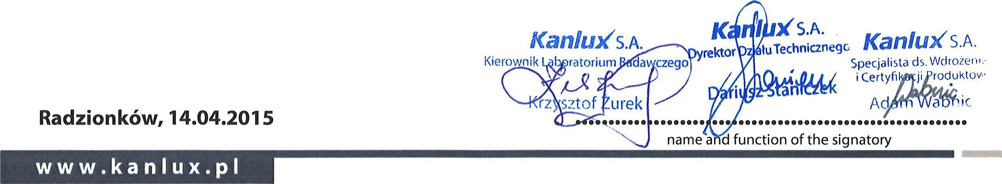
Kanlux SA Nr KIRS 00002861 39 • Sqd Rejonowy w Gliwicach, X Wydzial Gospodarczy KIRS
NIP: 645 243-27-93 • REGON: 240672104
ul. Objazdowa 1-3, 41-922 Radzionków, Polska Kapital zakiadowy: 35 500 000 zl oplacony w caloŠci tel. /32/388 74 00, fax /32/388 74 99, e-mail: kanlux@kanlux.pl ING BANK O/BYTOM: 82 1050 1 230 1000 0022 5379 7878

